**KYAMBOGO UNIVERSITY**

**FACULTY OF ENGINEERING**

**DEPARTMENT OF KYAMBOGO UNIVERSITY**

**FACULTY OF MECHANICAL AND PRODUCTION ENGINEERING**

BACHELOR OF INDUSTRIAL ENGINEERING AND MANAGEMENT

PROJECT DISSERTATION REPORT

DESIGN OF AN AUTOMATIC BILLET CUTTING MACHINE FOR CONTINOUS CASTING IN STEEL INDUSTRIES

BY

NAWATTI SARAH

21/U/IEE/7240/PE

A REPORT SUBMITED IN PARTIAL FULFILMENT OF THE REQUIREMENTS FOR THE AWARD OF THE DEGREE OF BACHELOR OF INDUSTRIAL ENGINEERING AND MANAGAMENT OF KYAMBOGO UNIVERSITY.

MAY, 2025

# APPROVAL

I hereby submit this dissertation report that was undertaken by

NAWATTI SARAH 21/U/IEE/7240/PE

This Final Year Project Dissertation has been developed under the supervision of the undersigned academic supervisor.

SUPERVISED BY

Name: **Ms. Atek Esther Phionah**

Signature: ……………………………………… Date:…………………………………………

# DECLARATION

I declare that any information in this report, except where indicated and acknowledged, is my original work and has not been presented before to the best of my knowledge.

NAWATTI SARAH

21/U/IEE/7240/PE

Signature……………………………………… Date……………………………………………

# DEDICATION

This Final Year Project Dissertation is dedicated to my beloved parent Mr. Lwasamadaala Samuel, my siblings, and my course mates. Your financial and moral support, as well as your diverse talents, have been instrumental in helping me achieve this academic accomplishment. Thank you for walking this journey with me.

# ACKNOWLEDGEMENT

I extend my sincere appreciation to my supervisor, Mrs. Atek Esther, for her invaluable guidance and support throughout the development of this Final Year Project Dissertation titled “Design of an automatic billet cutting machine for continuous casting in steel industries.” Her constructive feedback and encouragement kept me motivated and constantly seeking to improve the quality of my work. I would also like to thank the entire academic staff of the Department of Mechanical and Production Engineering, Kyambogo University, for their unwavering commitment to teaching and mentorship throughout my academic journey. Your dedication has played a vital role in shaping both my academic and professional growth. My heartfelt thanks go to my classmates for their companionship and the assistance they offered during our time at the university. The collaborative spirit and peer-to-peer learning environment we fostered in class greatly contributed to our collective success. Special appreciation goes to my close friends, whose presence made campus life memorable and whose support uplifted me during challenging times. May the Almighty bless you abundantly. I am deeply grateful to my family, who have been the cornerstone of my education. I dedicate this work especially to my parents, Mr. Lwasamadaala Samuel, for their unconditional love, care, and sacrifices that have enabled me to reach this milestone. May God bless you richly and reward your efforts. I also appreciate my siblings for their constant support in difficult moments and for being a source of joy and encouragement throughout my academic journey. Above all, I give glory and honor to the Almighty God, who has brought me this far. Without His grace and guidance, none of this would have been.

# ABSTRACT

Billet cutting machines are recognized as a sustainable alternative to traditional manual cutting methods. The machine operates on a rack and pinion mechanism driven by a 12V DC motor with a 12:1 gearbox. As the motor rotates, the pinion gear turns and moves the rack linearly carrying the gas cutting torch along a guided path. The torch is supplied with oxygen and acetylene ignites and heats the billet after which the focused oxygen jet cuts through the hot metal. The system is designed for a precise cutting speed of 12mm/s ensuring smooth, accurate, and consistent cuts. This automation eliminates manual intervention, increases operational efficiency and enhances safety during billet cutting in steel industries. Existing solutions are labor-intensive, costly, and environmentally detrimental. In this project, the billet cutting machine’s design prioritized energy efficiency, reduced HAZ emissions, and alignment with Uganda’s Vision 2040 and Sustainable Development Goal 8 AND 9. This machine offers a cost-effective, low-maintenance solution for steel industries, with potential for scalability.

Keywords: Pinion and rack gear, DC motor.

TABLE OF CONTENTS

APPROVAL i

DECLARATION i

DEDICATION ii

ACKNOWLEDGEMENT iii

ABSTRACT iv

LIST OF FIGURES vii

LIST OF TABLES viii

1.0 INTRODUCTION 1

1.1 Background 1

1.2 Statement of the problem 2

1.3 OBJECTIVES 2

1.3.1 Main Objective 2

1.3.2 Specific Objectives 3

1.4 Research Questions 3

1.5 Scope and Limitations of the Study 3

1.6 Justification 4

1.7 Significance of the Study 4

1.8 CONCEPTUAL FRAMEWORK 5

2.0 LITERATURE REVIEW 6

2.1 Introduction 6

2.2 Working Principle of billet cutting machines 6

2.3 Overview of existing billet cutting technologies 6

2.3.1 Torch Cutting 6

2.3.2 Mechanical Shearing 7

2.3.4 Water jet cutting 7

2.3.5 Plasma cutting 8

2.3.6 Laser cutting 9

2.3.7 Comparison of water jet, laser and plasma cutting 9

2.3. 8 Automation in cutting operations 10

2.3.9 DRIVE MECHANISMS 11

2.4 Control Mechanism: 13

2.4.1 Arduino microcontroller 13

2.4.2 Motor Driver 14

2.4.3 Relays 15

2.5 GAPS IN EXISTING LITERATURE 16

3.0 METHODOLOGY 16

3.1 Introduction 16

3.2 Research design 16

3.3 Selection of components of an automatic billet cutting machine 17

3.3.1 Frame 17

3.3.2 Rack and pinion system 18

3.3.3 Motor and Gearbox system 18

3.3.4 Torch cutting System 19

3.3.5 Control system 19

3.4 COMPONENT SELECTION AND SIZING 20

3.4.1 Pinion and rack mechanism 20

3.4.2 Speed (RPM) Calculations 24

3.4.3 Power requirements 25

3.5 MATERIAL SELECTION 25

3.6 Design of billet cutting machine 26

3.7 Prototyping and Fabrication 28

3.8 Testing and evaluation 28

4.0 RESULTS AND DISCUSSIONS 29

4.1 Introduction 29

4.2 Design Results 30

4.3 Effect of cutting speed on the billets 31

4.4Performance Evaluation 31

4.4.1 Cutting Speed Test 31

4.4.2 Travel torch Accuracy 32

4.4.3 Repeatability test 32

4.4.4 Stability and frame control 32

4.4.5 Control system responsiveness 33

5.0 LIMITATIONS, CONCLUSIONS AND RECOMMENDATIONS 34

5.1 LIMITATIONS 34

5.2 CONCLUSIONS 34

5.3 RECOMENDATIONS 35

REFERENCES 36

APPENDIX I: SOURCE CODE 39

APPENDIX II: WORKPLAN 44

APPENDIX III BUDGET 45

APPENDIX IV 46

# 

# LIST OF FIGURES

Figure 1 Shearing machine 9

Figure 2 Water jet cutting principle 9

Figure 3 Plasma cutting 10

Figure 4 Laser cutting 10

Figure 5 Arduino microcontroller Figure 6 Four channel relay module 14

Figure 7BTS7960 43A Double H-bridge High Power Motor Driver 15

Figure 8 Four channel relay module 15

Figure 9 Ultrasonic sensor 16

Figure 10 Circuit diagram 20

Figure 11 Solid works design of the rack 22

Figure 12 Isometric view of the billet cutting machine 27

Figure 13 Billet cutting table 28

Figure 14 Mechanism stand 28

Figure 15 Fabricated machine frame 29

# LIST OF TABLES

Table 1 Comparison between abrasive water jet, plasma beam, laser beam 11

Table 2 Methodology table 17

Table 3 Frame parameters and specifications 18

Table 4 Pinion and rack parameters and specifications 18

Table 5 Motor and gearbox parameters and specifications 19

Table 6 Torch cutting system parameters and specifications 19

Table 7 Control system parameters and specifications 21

Table 8 Material selection and justification 26

# 1.0 INTRODUCTION

## 1.1 Background

The iron and steel industry in Uganda have witnessed impressive growth, particularly driven by the booming housing and construction sectors in the region. Between 2010 and 2020, the industry recorded import growth of 20% per annum and export growth of 30% per annum, highlighting the increasing demand for steel products (Uganda Revenue Authority [URA], 2010). Initially reliant on imported billets, these mills have increasingly turned to using scrap iron, with significant contributions from companies such as the Madhivani Group’s East African Steel Corporation (1960s–1988), Steel Rolling Mills under the Alam Group (established in 1987), and more recently, Tembo Steel Mills, which began operations in 2002 (Obwana et al., 2014). These mills have enabled substantial import substitution, meeting growing demand and supporting the expansion of the sector (Obwana et al., 2014).

Steel production in Uganda typically involves melting iron ore and scrap iron in electric arc furnaces or induction furnaces, followed by continuous casting to form billets, slabs, blooms, and ingots—semi-finished products that are further processed into finished goods (Thomas, 2001). The ability to cut these products precisely is vital to maintaining material integrity and reducing waste during downstream processing (Irving, 2024).

Despite advances in casting technology, the cutting process when dealing with hot billets remains a challenge in Uganda’s steel mills. Traditionally, gas cutting methods, which utilize an oxy-fuel flame to melt and sever the metal, have been employed due to their simplicity and cost-effectiveness. However, this method presents several significant issues, one of the most critical being the formation of Heat-Affected Zones (HAZ). These changes can weaken the material, reducing its strength, hardness, and ductility, ultimately compromising the quality of the billet (Irving, 2024). Additionally, manual gas cutting often results in rough edges, which require further finishing, contributing to increased labor costs and material waste.

While gas cutting is still the predominant method in many Ugandan steel mills, there is a growing interest in improving this process, particularly through automation. Automation allows for more precise control of the cutting parameters, such as cutting speed, flame temperature, and cutting trajectory, which directly influence the formation and size of the HAZ (Irving, 2024). By integrating automated systems, it is possible to regulate the temperature more effectively during cutting, minimizing the heat impact on the billet and ensuring a cleaner, more uniform cut with fewer metallurgical alterations.

Investing in an affordable automated billet cutting system would not only improve the precision and safety of the cutting process but also enhance the competitiveness of Uganda’s steel industry on both a regional and global scale. By automating the cutting process, Uganda’s steel mills would reduce material waste, increase production efficiency, and maintain higher-quality standards. This automation would provide a crucial step toward modernizing Uganda’s steel industry, ensuring that it can meet the growing demand for steel products while improving operational sustainability (Thomas, 2001).

## 1.2 Statement of the problem

The manual approach of billet cutting which involves using open flames and high temperatures, presents several safety risks to workers, including exposure to fires and burns (Kumar & Singh, 2020). The thermal effects generated during gas cutting lead to Heat-Affected Zones (HAZ), where the steel's microstructure is altered, resulting in warping and reduced material strength, ultimately compromising the quality of the billets (Mishra et al., 2021). Also, the manual nature of the process causes inconsistencies in product quality, with irregular cuts and dimensional inaccuracies that increase scrap rates and require additional finishing. These inefficiencies limit the industry's ability to compete effectively in the global market. To address these challenges, there is an urgent need for the design and implementation of an automatic gas cutting machine using a gas torch. Automating the cutting process would not only enhance cutting precision but also reduce safety risks, improve product quality, and lower operational costs, enabling Uganda’s steel industry to modernize and remain competitive in both local and regional markets.

## 1.3 OBJECTIVES

### 1.3.1 Main Objective

The main objective for the research is to design and fabricate a hot billet cutting machine

### 1.3.2 Specific Objectives

1. To determine the components and the design parameters of an efficient hot billet cutting machine
2. To develop a 3D prototype of the hot billet cutting machine.
3. To fabricate and test the working prototype of the hot billet cutting machine.

## 1.4 Research Questions

1. What are the parameters needed in order to design an efficient hot billet cutting machine?

2. What are the requirements needed to construct a prototype of the hot billet cutting machine?

3. What is needed to evaluate the performance of the prototype of the hot billet cutting machine?

## 1.5 Scope and Limitations of the Study

The study will explore the limitations and inefficiencies of the current manual and semi-automated billet cutting systems in major steel plants such as Roofings group, Steel and tube industries, and Tembo Steels. It will assess the technical and operational requirements necessary for implementing a fully automated billet cutting system including hardware components, software integration and energy consumption considerations. The study will provide a comparative analysis of different cutting technologies available in the market such as flying shear cutters, hot saw cutters and hydraulic cutting machines and evaluate their suitability for the steel industry. The study does not extend to the full automation of other steel production processes beyond billet cutting instead it remains focused on optimizing the billet cutting processes as a critical element of continuous casting in steel production. This study will focus on designing a hot billet cutting machine specifically tailored for use in Ugandan manufacturing industries engaged in metal fabrication. The research will primarily involve theoretical design work followed by practical fabrication and testing phases.

Limitations include potential constraints related to material availability during fabrication processes as well as access to specific testing facilities required for evaluating machine performance under real-world conditions.

## 1.6 Justification

The development of an automated hot billet cutting machine is essential for addressing key operational challenges in Uganda’s steel industry. Currently, most steel manufacturers rely on manual gas cutting methods, which are labor-intensive, prone to safety hazards, and result in inconsistent billet sizes. These inefficiencies lead to material waste, increased production costs, and compromised product quality, limiting the competitiveness of Ugandan steel products in both local and regional markets. By introducing automation into the billet cutting process, this project offers a reliable solution that ensures precision, enhances worker safety, and reduces waste. The automated system will also minimize human error, lower operational costs, and improve production speed. These benefits align with Uganda’s broader industrialization goals under Vision 2040, supporting sustainable manufacturing and economic growth. Ultimately, the project will empower steel manufacturers to produce high-quality billets that meet market demands while maintaining efficiency, safety, and environmental responsibility.

## 1.7 Significance of the Study

The design and implementation of an automated billet cutting machine directly support Uganda’s national development priorities and international sustainability commitments. Uganda’s Third National Development Plan (NDPIII) emphasizes the need for industrialization, technological innovation, and sustainable manufacturing to drive economic transformation and job creation. By introducing automation into the steel sector, this project addresses key objectives under NDPIII, including increased value addition in industry and enhanced productivity in manufacturing. It strengthens Uganda’s capacity for industrial growth by promoting efficiency, competitiveness, and safer working environments—core elements in the country's Vision 2040.

Furthermore, the project aligns with several United Nations Sustainable Development Goals (SDGs). It contributes to SDG 9 (Industry, Innovation and Infrastructure) by introducing modern and resilient manufacturing technologies, and to SDG 8 (Decent Work and Economic Growth) through safer work conditions and improved operational efficiency. By minimizing material waste and reducing energy consumption, the project also supports SDG 12 (Responsible Consumption and Production) and SDG 13 (Climate Action). The transition from manual to automated systems promotes sustainable industrial practices, enabling Uganda’s steel industry to reduce its environmental footprint while meeting growing domestic and regional demand for steel products. Ultimately, this research helps bridge the technological gap in Uganda’s manufacturing sector, empowering local industries to participate more effectively in global value chains and contribute to inclusive economic development.

## 1.8 CONCEPTUAL FRAMEWORK

**Independent variables Dependent variables**

1. Quality of the cut
2. Cutting time per billet
3. Thermal deformation of the cut area
4. Cutting speed
5. Motor torque and voltage
6. Gearbox ratio
7. Billet temperature
8. Gas flow rate
9. Friction in the rack and pinion mechanism
10. Gas purity
11. Heat loss to the surrounding

**Intervening variables**

# 2.0 LITERATURE REVIEW

## 2.1 Introduction

Continuous casting of steel is the preferred method for producers, replacing ingot casting. Automated billet cutting machines are crucial for efficiency, precision, and continuity. This literature review explores technological developments, critical parameters, design considerations, and cost analysis of automated billet cutting systems, aiming to achieve consistent product quality, minimize labor costs, and enhance safety in hazardous working conditions.

## 2.2 Working Principle of billet cutting machines

The process in the existing machines involves loading of rods in auto loader, triggering of rods into the feeder bed, feeding of rod into the cutter and cutting of rod into billet. The loading of the rods over the rod resting tray of the auto loader is done manually by the operator. The Arm is placed under the rod resting tray. The Arm is also known as trigger, which is used to push the rod from the tray to the feeder bed. The trigger is automated which is already existed in the machine. It is made to adjust according to the diameter of the rod. Using the shuttle vice, which has the horizontal movable and fixed jaws and vertical movable jaw and the rod is moved towards the cutter. And these jaws hold the rod firmly and move towards the cutter. In this process the rod is held firmly by the main vice, which have same jaws as in the shuttle vice but has shorter length than it, because to held the rod firmly during cutting. The cutter is moved towards the job horizontally and cut the rod into the billet(Palani et al., 2016).

## 2.3 Overview of existing billet cutting technologies

### 2.3.1 Torch Cutting

Torch cutting, also known as oxy-fuel cutting, is a thermal cutting process that utilizes the combustion of oxygen and a fuel gas (commonly acetylene) to cut through metals. A flame produced by burning a mixture of oxygen and acetylene heats the metal until it reaches its ignition temperature. Once heated sufficiently, pure oxygen is directed onto the heated area, causing rapid oxidation and effectively “burning” through the metal. Torch cutting offers several advantages such as versatility, cost effectiveness, portability and ability to cut thicker materials. Torch cutting its doesn’t require a constant power supply, only an oxygen and fuel source, which makes it suitable for environments without stable electrical access.

One of the disadvantages of torch cutting is that it can lead to significant heat affected areas. The localized heating during cutting process can cause changes in the microstructure of steel, leading to potential weakening or distortion.

Additionally, torch cutting produces more slag and generates fumes which require proper ventilation and handling to maintain a safe working environment. The process also typically results into lower precision compared to other cutting methods like plasma or laser cutting which can draw back when accurate cuts are needed in a continuous casting operation(Mohan, 2025).

### 2.3.2 Mechanical Shearing

This method involves cutting metal billets into specified lengths using a shearing mechanism that applies mechanical force to sever the material. The shearing machine typically consists of two blades—one stationary and one movable—that come together to cut through the billet. The design of these blades can vary based on the thickness and type of material being processed. The speed at which the blades operate can also be adjusted to optimize cutting efficiency and minimize thermal distortion. Mechanical shearing is primarily used for cutting long lengths of steel or other alloys into shorter, manageable pieces that can be further processed or shipped(Bhavesh, n.d.).

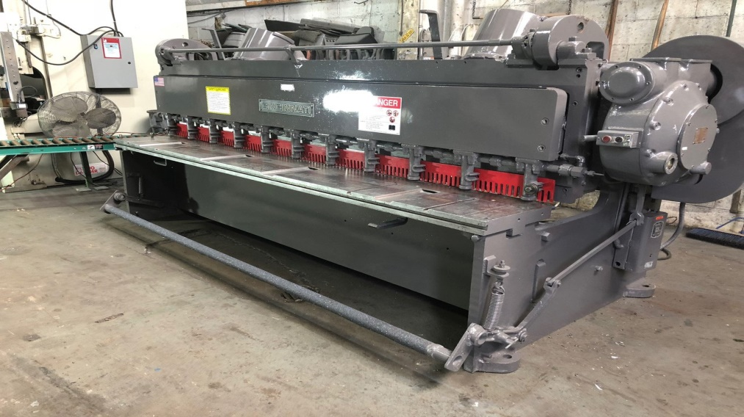

Figure 1 Shearing machine

### 2.3.4 Water jet cutting

Water jet cutting is a method using thin water jets under high pressure with abrasive slurry to cut materials through erosion. Invented in 1968, it has rapidly developed since the early 1980s. This emerging technology is used in various industries for processing engineering materials and has numerous advantages over other non-conventional cutting techniques. The cutting process involves a pump feeding water to an abrasive mixing chamber, forming a stream of hydro-abrasive that can cut through even the toughest materials. High-pressure water pumps are available from 276 MPa to 689 MPa.

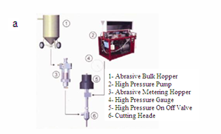

Figure 2 Water jet cutting principle

### 2.3.5 Plasma cutting

Plasma cutting is a technique for cutting steel and other metals with changing thickness. The method involves melting metal and extracting the sliced metal from the slot. This is performed by generating a concentrated plasma arc with high kinetic energy. Plasma cutting involves high temperatures in both the core plasma arc and the high-speed plasma stream. An electric arc is formed between the tungsten electrode and the cut object. The development principles are as follows: by passing the compressed form of the arc for the phenomenon that is a result of ionization and high-power density, a stream of plasma can be formed. The most usually utilized gas plasma cutting is air, but also in(Bhavesh, n.d.).

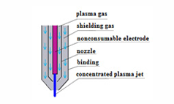

Figure 3 Plasma cutting

### 2.3.6 Laser cutting

Laser cutting is a method that allows a laser to cut diverse materials using the cutting jet's high-point by introducing high-purity energy and technical gases. Laser radiation is unique, making it almost impossible to achieve using other technologies. There is a lot of power in this pick, but it only covers a small portion of the spectrum. Its qualities include continuous radiation in both time and space, as well as the most polarised beam with low divergence. Depending on the cutting equipment, three methods are used: burning, melting, or sublimation. The process of creating a laser beam typically requires activating a lasing material using electrical discharges or lamps inside a closed container. The beam is reflected internally by a half mirror, until it reaches sufficient energy to escape as monochromatic coherent light. Generally, the narrowest part of the focused is less than 0.32 mm in diameter. Of course, taking into account the thickness of the material, the width of the gap as small as 0.10 mm are possible

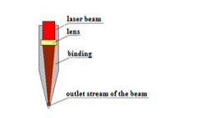

Figure 4 Laser cutting

### 2.3.7 Comparison of water jet, laser and plasma cutting

The table suggests that abrasive water jet cutting is the best solution, as it outperforms other methods in multiple categories. However, this conclusion is not absolute. First, Table 1 provides a comparison of all relevant parameters, but the significance of each factor depends on the specific requirements of a given application. In many cases, only certain properties are critical, and these selected attributes determine the best choice for a particular use. To provide a more focused comparison, I have analysed three different metal-cutting methods based on key areas that I consider crucial. Each of the six categories is introduced in a new paragraph, with an additional explanation to clarify the importance of the comparison.

Table 1 Comparison between abrasive water jet, plasma beam, laser beam

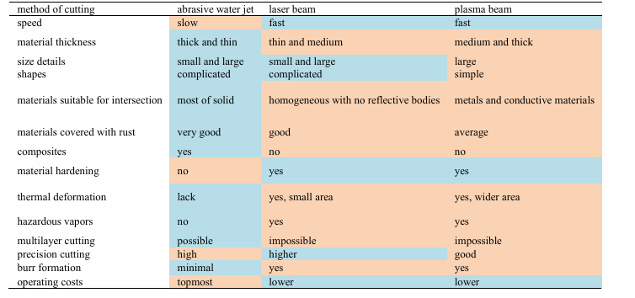

Various cutting technologies were analyzed, including oxy-fuel, plasma, and laser cutting. While laser cutting offers high precision, it requires significant energy and maintenance, making it less suitable for high-throughput, continuous casting environments like Uganda’s steel plants. Plasma cutting is faster and more efficient for large billets but may increase costs due to high energy usage. Comparatively, oxy-fuel cutting aligns well with Uganda’s needs, offering a balance of speed, cost-effectiveness, and compatibility with hot billets.

### 2.3. 8 Automation in cutting operations

#### 2.3.8.1 Counter Method

This method is implemented with a counter module added to the PLC and a sensor placed on the gear unit or relay in the withdrawal straightener unit. The sensor continuously sends data of the detected metal to the counter module. The module counts and waits for the operator to enter the length of the system, and commands the PLC to cut product when it reaches the desired length. There are a few critical issues when implementing the counter method as:

* The failure of the sensor in the area may cause cutting at wrong length of the billet. Since the CCM environment is very hot, there is a high probability of fault with the sensor.
* If the gear or rheometer to which the sensor has detected has jammed or a gap has been created, the excess or missing run will cause the billet to be cut incorrectly.
* Malfunction of the counter module in the PLC results cutting process incorrectly.
* The material cost used in the field and the module cost used in the PLC are disadvantages of the counter method.

#### 2.3.8.2 Contact Plate Method

This method is applied by mounting a limit switch in front of the BCM in such a way that the length of the billet is set in front of the BCM and cutting command is given when the billet hits the switch. Contact plate method is rarely preferred in CCM. Because, the switch mounted in front of the BCM causes breakdowns frequently because of the high billet temperature. For example, deformation of the operating head of the limit switch is highly possible which causes the billet passing without cutting(ZHAO et al., 2021).

### 2.3.9 DRIVE MECHANISMS

#### 2.3.9.1 Hydraulic drive

Hydraulic drive systems are particularly well-suited for applications that require substantial force and power. These systems use hydraulic pumps, motors, and actuators to transfer energy, making them ideal for billet cutting. Hydraulic actuators can deliver significant force, which is crucial for cutting hot billets with high precision. The force can also be easily controlled, ensuring that the machine operates smoothly even under the demanding conditions of high temperatures and varying billet sizes (Yang et al., 2022). Hydraulic systems are often employed in environments where cutting precision and the ability to handle high-pressure loads are essential. If the automated billet cutting machine uses a hydraulic system, we need to determine the required flow rate and pressure for the hydraulic pump.

#### 2.3.9.2 Pneumatic drives

Pneumatic systems, powered by compressed air, are typically faster than hydraulic systems and are known for their quick on-off operation. While pneumatic drives are often used in lighter industrial tasks, they are less suitable for heavy-duty billet cutting due to their limited force output. However, for smaller-scale applications or where high-speed cutting is required, pneumatic actuators may be utilized. These systems are advantageous for operations that demand rapid movements rather than sustained force (Liu et al., 2021). Pneumatic cylinders are useful when the cutting machine needs to execute high-speed, repetitive motions without requiring heavy force.

#### 2.3.9.3 Servo Motors with Feedback Control

Servo motors, particularly when combined with feedback control systems, are ideal for high-precision applications such as billet cutting. These systems allow for real-time adjustments in speed and force, ensuring the cutting blade is positioned accurately during each operation. The use of closed-loop control enhances the system’s ability to adapt to variations in billet size and material properties, optimizing the cutting process. This results in higher precision, reduced waste, and improved overall efficiency (Yang et al., 2021). Servo motors are especially useful when high accuracy is required for cutting billets of various sizes.

#### 2.3.9.4 Mechanical Drives (Gear Systems)

Mechanical drives, such as gear systems and belts, are often integrated into automatic cutting machines for transferring power. These systems are simple, cost-effective, and provide high reliability. Gearboxes in mechanical systems help in reducing speed while increasing torque, which is crucial when cutting billets at high temperatures. Gear systems are often combined with electric or hydraulic drives to create a more efficient and versatile mechanism, providing both speed and power control (ZHAO et al., 2021)Mechanical drives are particularly effective in applications where consistent, reliable performance is needed.

#### 2.3.9.5 Electric motor drives

Electric drive motors are generally classified into various types, with AC (Alternating Current) and DC (Direct Current) motors being the most common. AC motors, including induction and synchronous motors, are preferred in industrial settings for their reliability, lower maintenance requirements, and efficiency. They are particularly compatible with Variable Frequency Drives (VFDs), which allow operators to control the motor speed by adjusting the frequency and voltage supplied to the motor, thus optimizing energy use (Bose, 2019). In high-demand applications like billet cutting, VFDs paired with AC motors offer the precision and flexibility required to handle different material properties, as they enable smooth acceleration and deceleration without abrupt mechanical stress.

##### 2.3.9.5.1 DC motor

DC motor The DC motor is the drive system of the pinion and rack mechanism, responsible for converting electrical energy into mechanical motion. Brushed and brushless DC motors (BLDC) are commonly used due to their compact size and high torque efficiency. However, BLDC motors are increasingly preferred because of their longer lifespan, higher torque-to-weight ratio, and lower maintenance requirements. (Kumar, P., Singh, J., & Kaur, 2021). The appropriate power range for these motors typically falls between 100–500W, depending on factors such as soil hardness and the working width of the weeder. (Dhakad, D. S., Sahu, P., & Jhariya, 2021). With a rated torque of 6 N-m (4.4 ft-lb) and a rated load of 60 Watts, this motor is perfect for a wide range of applications. It features M6 screw holes for easy mounting and a 3/8" shaft with a 1 flat ("D" shaft) where flat to OD is 0.322" and the length of the shaft is 0.886" long.

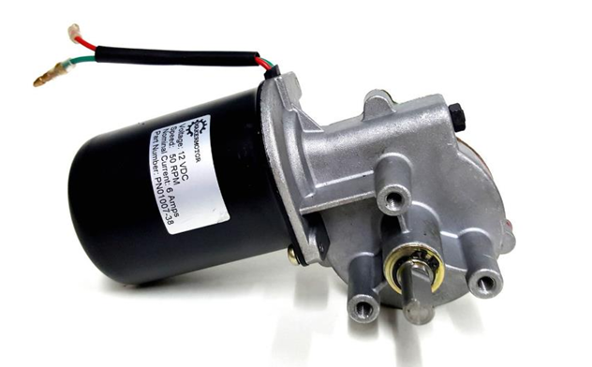

Figure 5 shows the BLDC 12V motor (PN01007-38 - 3/8" D Shaft Electric Gear Motor 12v Low Speed 50 RPM

## 2.4 Control Mechanism:

### 2.4.1 Arduino microcontroller

The Arduino microcontroller acts as the central control unit. It receives inputs from the Ultrasonic sensor and processes them to determine the appropriate actions. Based on the sensor readings, the microcontroller controls the DC motors forward and reverse motion through a motor driver. It also manages the solenoid valves responsible for regulating the flow of oxygen and acetylene gases to the cutting torch, switching them ON or OFF through connected relays. Additionally, it reads input from an ultrasonic sensor to detect the presence or position of a billet, ensuring that the cutting process only begins when a billet is properly positioned. The Arduino interfaces with START and STOP push buttons to allow the operator to manually control the system when needed. A step-up/down voltage converter ensures the Arduino receives a stable power supply, even though the actual voltage regulation is handled externally

 

Figure 6 Arduino microcontroller Figure 7 Four channel relay module

### 2.4.2 Motor Driver

The BTS7960 is a high-current full-bridge motor driver module. The Key features are: Input voltage: 6V to 27V, Maximum allowable current: 43 A, PWM capability: up to 25 kHz, Two PWM output pins for speed control in direct and reverse directions, Two EN output pins to control motors, Two IS input pins to protect against high current and heat

These modules control DC motors using PWM (Pulse Width Modulation) technique. These modules convert a constant input voltage to a variable voltage for motor. The speed can be controlled by changing the DC motor voltage. PWMs usually have a fixed frequency and can be controlled by controlling the time that the pulse is HIGH (Duty Cycle).

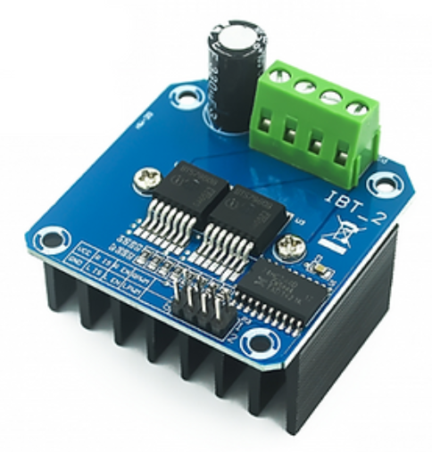

Figure 8BTS7960 43A Double H-bridge High Power Motor Driver

### 2.4.3 Relays

Relays serve as electrically operated switches that allow the Arduino to safely control the activation and deactivation of the gas flow through solenoid valves, as well as the movement of the cutting torch via the motor.

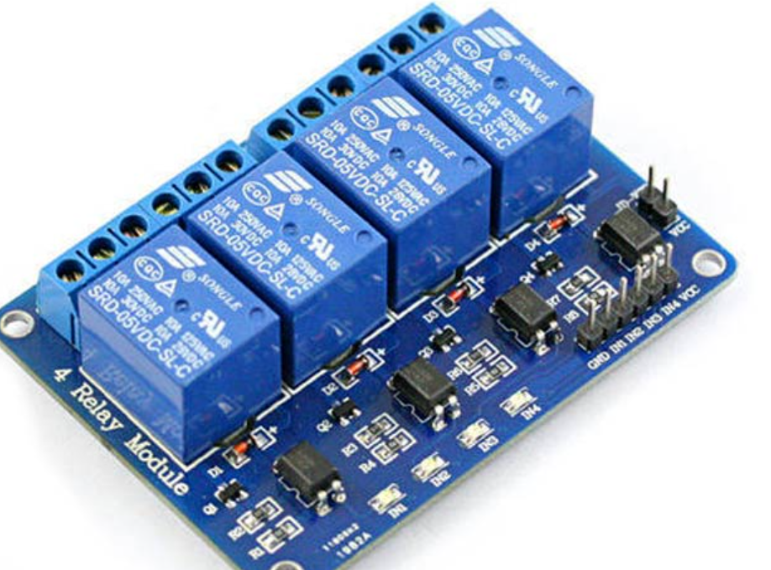

Figure 9 Four channel relay module

The ultrasonic sensors emit ultrasonic waves and convert the reflected sound into an electrical signal to determine the distance of an approaching billet and sends signals to the micro controller for interpretation. The decision to use this type of sensor was reached after careful comparisons were made with several other sensors including IR sensors, Inductive sensors, and proximity sensors, on basis of reliability, cost effectiveness and suitability for the project requirements.



Figure 10 Ultrasonic sensor

## 2.5 GAPS IN EXISTING LITERATURE

Research on billet cutting technologies is limited, with limited research on integrating advanced automation techniques like machine learning, real-time sensor feedback, and predictive maintenance, which could enhance precision, reduce waste, and optimize operational parameters.

Secondly, existing literature on cutting efficiency and material impact is limited, lacking comprehensive studies on energy consumption and sustainability, especially in unstable power grids like Uganda, and hybrid systems integrating renewable energy sources.

Moreover, while there is significant documentation on cutting blade materials, the impact of different coatings and heat-resistant materials on blade longevity remains underexplored. This is particularly relevant for hot billet cutting applications where high temperatures accelerate wear and tear. Investigating novel composite materials or self-cooling blade technologies could enhance durability and performance.

Hence research, on billet cutting technologies for developing economies is limited, focusing on large-scale production in developed nations, overlooking affordability, maintenance complexity, and local conditions

# 3.0 METHODOLOGY

## 3.1 Introduction

The design of a billet cutting machine was undertaken through a systematic approach that addresses the specific challenges involved in the manual billet cutting machine. This was accomplished by employing various methodological strategies to effectively achieve the research objectives. The objectives of the project dictated the selection and implementation of appropriate methodologies.

## 3.2 Research design

Table 2 Methodology table

|  |  |  |
| --- | --- | --- |
| OBJECTIVE | METHOD | DESCRIPTION |
| To determine the components and the design parameters of an efficient hot billet cutting machine | * Literature review * Component analysis and selection | * Existing technologies were reviewed to identify key specifications * Components were chosen basing on cost requirements, specifications and efficiency |
| To develop a 3D prototype of the hot billet cutting machine | * Conceptual design * Design optimization | * Solid works software was used to develop the design to visualize the machines structure |
| To fabricate and test the working prototype of the automatic billet cutting machine. | * Prototyping * Testing and evaluation | * The prototype was developed using the selected and designed components * Testing and evaluation was conducted to determine the torch travel accuracy, repeatability among others |

## 3.3 Selection of components of an automatic billet cutting machine

### 3.3.1 Frame

This component provides a rigid foundation for mounting all the other components: gearbox, motor, rack and pinion, torch, guide rails and control unit. The frame absorbs vibrations generated during cutting operation and supports the movement of the cutting torch assembly to ensure alignment.

Table 3 Frame parameters and specifications

|  |  |
| --- | --- |
| **Design Parameters** | **Design specifications** |
| Dimensions (length, width, height) | Millimeter(mm) |
| 1. **Billet table** |  |
| Length(L) | 1540mm |
| Width(b) | 440mm |
| Height(t) | 580mm |
| Material | Mild steel (AISI 1020) |
| 1. **Mechanism Stand** |  |
| Length(L) | 510mm |
| Width(b) | 200mm |
| Height(t) | 150mm |
| Material | Mild steel (AISI 1020) |

### 3.3.2 Rack and pinion system

The rack converts rotary motion into linear motion to move the torch horizontally along the billet.

The pinion is attached to the motor shaft via a gearbox, as the pinion rotates, it engages with the teeth of the rack driving it in a straight line.

Table 4 Pinion and rack parameters and specifications

|  |  |
| --- | --- |
| **Design parameters** | **Specifications** |
| Rack material | Hardened carbon steel |
| Pinion material | Hardened carbon steel |
| Module | 2-4 mm |
| Number of teeth | 24 teeth |
| Pitch circle diameter | 48mm |
| Pitch(p) | = $π×m$ |
| Rack length | 120mm |
| Pressure angel | 200 |
| Safety factor | 1.5-2 |

### 3.3.3 Motor and Gearbox system

The motor provides controlled rotary motion, which is then transmitted through the gearbox with a reduction ratio. The gearbox reduces motor speed while increasing the torch.

The output shaft of the gearbox is connected to the pinion.

Table 5 Motor and gearbox parameters and specifications

|  |  |
| --- | --- |
| Design Parameters | Specifications |
| Motor type | DC motor |
| Rated voltage | 13.5V DC |
| Rated current | 6A |
| Motor efficiency | 75-85% |
| No load speed | 50-100 RPM |
| Gearbox type | Spur gear |
| Gearbox ratio | 12:1 |
| Backlash | < 0.5mm |

### 3.3.4 Torch cutting System

This consists of a gas cutting torch mounted on a mechanical clamp that moves horizontally along the billet, delivering a high temperature flame along the desired cutting path.

The torch is supplied with oxygen and acetylene through regulated valves and hoses and the nozzle is positioned at an optimal distance above the billet surface.

Table 6 Torch cutting system parameters and specifications

|  |  |
| --- | --- |
| Parameters | Specifications |
| Torch type | Oxygen-acetylene cutting torch |
| Material to cut | Steel billet (120mm by 120mm) |
| Torch mounting | Mechanically clamped to rack assembly |
| Torch distance from billet | 3-5mm above |
| Valve control | Solenoid controlled valves |
| Nozzle size | 1-2 |
| Gas flow rate | Oxygen: 100-150 L/min  Acetylene: 40-50 L/min |
| Flame type | Neutral flame |
| Ignition method | Spark igniter |

### 3.3.5 Control system

The system uses an Arduino Uno to control the DC motor that drives the pinion and rack on which the torch assembly is connected by a mechanical clamp. The system automatically detects objects via ultrasonic sensor and executes a complete cutting cycle including gas purging, ignition and the precise motor reverse and forward motion

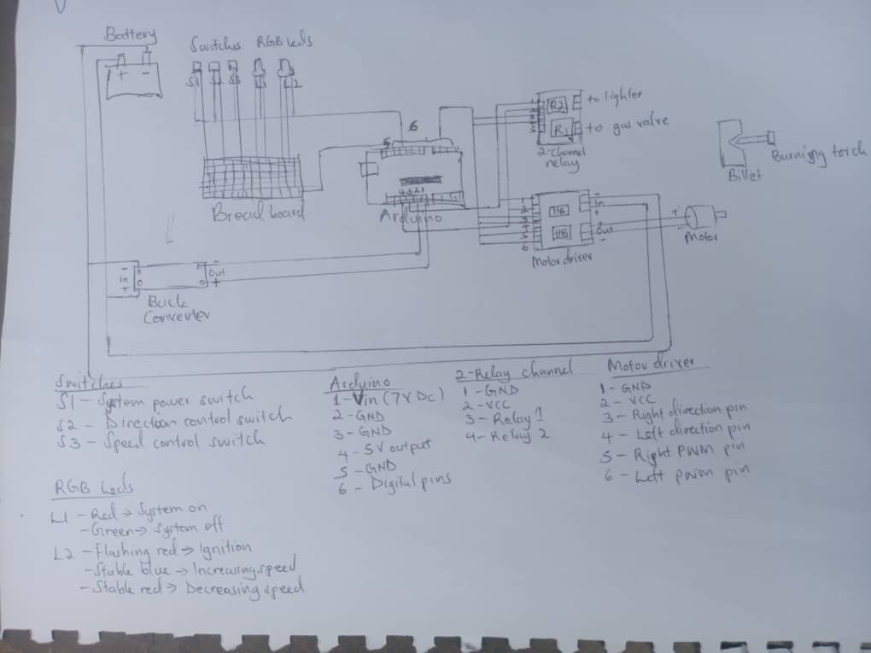

Figure 11 Circuit diagram

Table 7 Control system parameters and specifications

|  |  |
| --- | --- |
| Parameter | Specification |
| Controller type | Arduino UNO |
| Input voltage | 12-24V DC |
| Motor driver | BTS7960 |
| Direction control | BTS7960 |
| Valve actuation | 24 V DC solenoid valves |
| Billet detection | Ultrasonic sensor |
| Emergency stop | Manual button |

## 3.4 COMPONENT SELECTION AND SIZING

### 3.4.1 Pinion and rack mechanism

A rack and pinion are used to convert rotary to linear motion

The design and sizing involve determining,

* Rack length, width, and thickness
* Pinion gear diameter and number of teeth
* Gear ratio and module calculation
* Material selection
* Strength and load analysis
* Sizing the rack

**Rack length(Lr)**

Where h= maximum linear movement of of the rack

Sf = Extra margin

$$L_{r}=h +S_{f}$$

$$h=120mm$$

$$S_{f}=30mm$$

$$L_{r}=150+30$$

$$L_{r}=150mm$$

* **Linear travel speed(Vs)**

Vs $=\frac{Travel distance}{Desired cutting time}$

$$=\frac{120mm}{12s}$$

$$=12mm/s$$

* **Rack width(br) and thickness(tr)**

For durability,the rack width and thickness are chosen based on standard practices.

$$b_{r}=40mm$$

$$t_{r}=40mm$$

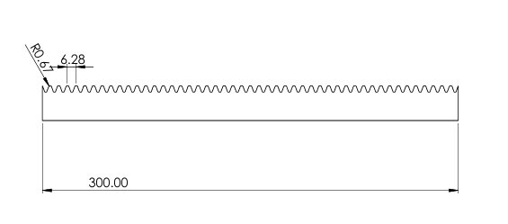

Figure 12 Solid works design of the rack

* **Sizing the pinion gear**

The pinion gear engages with the rack to convert linear motion into rotation. They key parameters are;

Pinion pitch circle diameter

$$D_{p}=N_{p}×m$$

Where Np = Number of pinion teeth

m = module(tooth size)

$D_{p}=24$ $×2$

$=48mm$

Pinion Outer Diameter = $m×(Np+2)$

$=2$ $×(24+2)$

$=50mm$

* **Rack to pinion relationship**

$$s=rθ$$

where

s= rack displacement

r= pinion radius

$θ$ =pinion radius in radians

$$=\frac{D_{p}}{2}$$

$$r=\frac{48}{2}$$

$$r=24mm$$

$$θ=\frac{s}{r}$$

$$θ=\frac{150}{24}$$

$$θ=6.25 rads$$

* **Material selection**

The rack and pinion should withstand repeated heat applications without excessive wear

Rack: Mild steel(C25) (Hardness: 180-220HB)

Pinion: Hardened steel(AISI 1045) (hardnesss: 250-300HB)

* **Rack height(h) and tooth depth**

For module= 2mm, the full depth involute standard gives

* Addendum(a)=m=2mm
* Dedendum(d)=1.25mm=2.5mm
* Tooth depth= $a+d$ = 4.5mm
* Rack height: $\sim 15-20mm$
* **Strength analysis**

The torque on the pinion shaft is calculated as

$$T=F_{r}× r$$

Where;

Fr = force exerted by the rack

r =pinion radius

* **Torque required at the rack**

1. **Total moving mass**

|  |  |
| --- | --- |
| **COMPONENT** | **MASS(KG)** |
| Oxy-fuel torch | 1.0 |
| Mechanical clamp | 0.5 |
| Rack segment (moving part) | 1.5 |
| Carriage | 1.7 |
| Hoses and connectors | 0.3 |
| **Total** | **5 kg** |

1. **Linear acceleration**

s2

1. **Inertial force**

**Finertia=**

1. **Frictional force**

**Ffriction**

Coefficient of friction, µ= 0.2

$=0.2×5×9.81$

=9.81N

1. **Total force**

**Ftotal**Finertia+Ffriction

1. **Torque Requirements**

T= $\frac{Ftotal ×D}{2×μ}$

= $\frac{10.81 ×0.048 }{2×0.75}$

$=0.346$ Nm

Adding 3x Safety margin, Torque required;

$$T=0.346×3=1.038 Nm$$

### 3.4.2 Speed (RPM) Calculations

* **Pinion RPM**

$$N=\frac{Vs×60}{π ×D}$$

$$N=\frac{0.012 ×60}{π×0.048}$$

$=4.77 RPM$

* **Angular velocity**

$$ω=\frac{2V}{D}$$

$ω=\frac{2×0.012}{0.048}$

$$=0.5 rad/s$$

### 3.4.3 Power requirements

* **Mechanical power output**

Mechanical power output is given as 0.02HP.

1HP = 746W

$$P_{out}=0.02 x 746=14.92W$$

Mechanical power output is 14.92W

* **Electrical input power**

Since mechanical power output is related to power input by efficiency,

$$P_{out}=P_{in} x efficiency$$

Assuming an efficiency of 80% (0.8), $P_{in}=\frac{14.92}{0.8}$ = 18.65W

Electrical input power is 18.65W.

## 3.5 MATERIAL SELECTION

Table 8 Material selection and justification

|  |  |  |  |
| --- | --- | --- | --- |
| **S/N** | **COMPONENT** | **MATERIAL** | **JUSTIFICATION** |
| 1 | Frame | Mild Steel (AISI 1020) | Selected for its excellent weldability and mechanical strength at ambient temperatures. |
| 2 | Rack | EN8 Alloy Steel (Surface Hardened) | EN8 offers high tensile strength and wear resistance. Given its linear engagement with the pinion and proximity to the billet, it is surface hardened to reduce wear under moderate thermal exposure. |
| 3 | Pinion Gear | EN24 (Nickel-Chromium Steel) | Chosen for its ability to withstand high contact stress and shock loads during intermittent operation. EN24 is also moderately heat-resistant, making it suitable near the billet. |
| 4 | Torch holder | Stainless Steel (Grade 304) | As it is exposed to radiant heat from billets at 900–1200°C, stainless steel 304 provides oxidation resistance, thermal stability, and adequate strength at elevated temperatures. |
| 5 | Torch Nozzel | Copper Alloy with Stainless Steel Tip | Copper's excellent thermal conductivity helps dissipate heat quickly, reducing deformation, while the stainless steel tip resists erosion from the high-temperature flame and cutting slag. |
| 6 | Shaft | EN8 (Oil Hardened) | EN8 provides sufficient torsional strength and dimensional stability under mild thermal stress. |
| 7 | Motor mount | Mild Steel with thermal insulation | The mount remains structurally stable and provides easy fabrication. Thermal insulation is added to shield the motor from radiant billet heat, enhancing lifespan and performance |
| 8 | Gas pipes | Stainless steel (316) | Required for high corrosion resistance and strength under elevated temperatures and pressures, especially in proximity to the flame and hot billet. SS316 resists oxidation from oxygen and acetylene. |
| 9 | Base Plate | Mild Steel | Mild steel offers adequate strength. |
| 10 | Fasteners | High tensile alloy  (Grade 8.8 or 10.9) | Used to secure assemblies exposed to mechanical vibration and some thermal stress. These grades ensure high preload strength and mechanical integrity under fluctuating loads. |

## 3.6 Design of billet cutting machine

Solid works was used to design the billet cutting machine. In the Solidworks environment, different parts were designed alone and then assembled in the assembly environment.

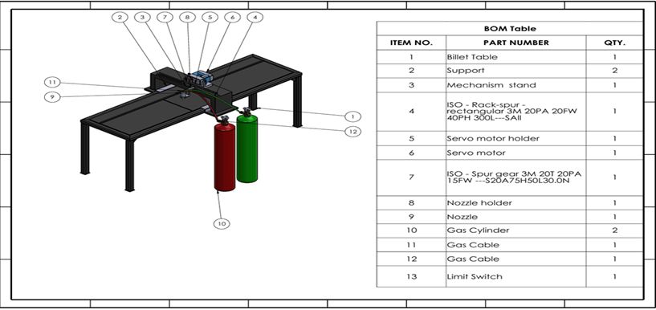

Figure 13 Isometric view of the billet cutting machine

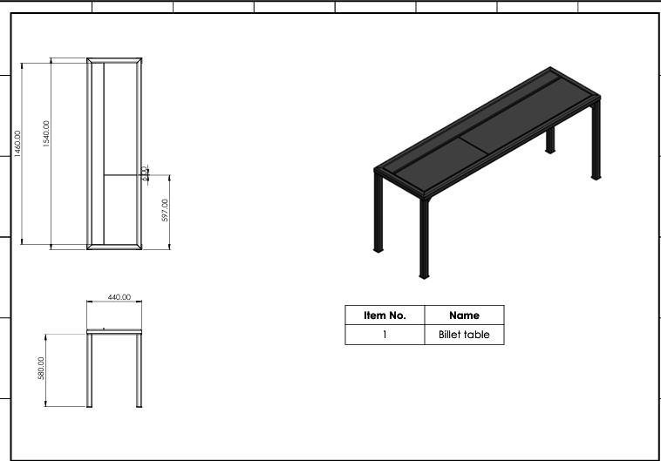

Figure 14 Billet cutting table

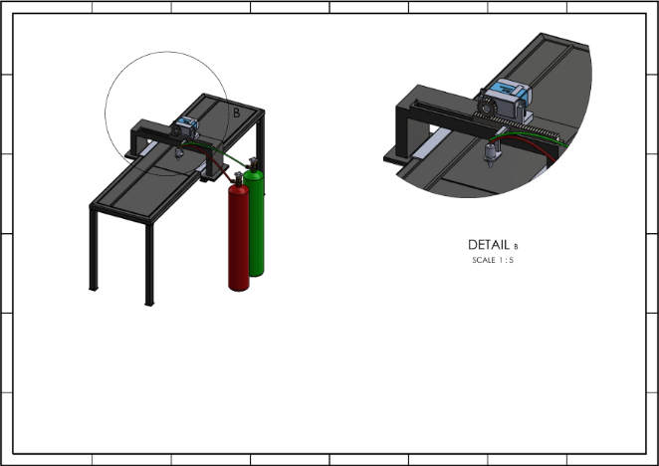

Figure 15 Mechanism stand

## 3.7 Prototyping and Fabrication

The billet cutting machine was fabricated using selected materials and components based on the approved design specifications by integrating the motor, gearbox, pinion and rack, mechanical clamp and torch assembly into a simple operational unit.

## 3.8 Testing and evaluation

The tests were conducted using billets at room temperature to evaluate the cutting motion of the system, cutting path alignment. It included billets of $30mm×30mm$ dimensions.

The following key performances indicators were evaluated:

* Travel accuracy
* Repeatability
* System responsiveness
* Stability and flame control

I obtained five samples of the steel billet and marked the desired linear path that the torch should follow during cutting and then operated the billet cutting and then recorded the results.

# 4.0 RESULTS AND DISCUSSIONS

## 4.1 Introduction

This chapter presents the results and discussions obtained from the testing of the prototype of the automatic gas billet cutting machine. During the testing, mild steel billets of thick sections with a cross sectional dimension of $30mm×30mm$ and a cutting length of 100mm all tested at room temperature.

A total of five trials were carried out to evaluate the systems cutting accuracy, speed, control, responsiveness and motion control. The target linear speed of 12mm/s was maintained as the benchmark to assess performance stability. The results obtained were analyzed and discussed in this chapter highlighting successes, limitations and areas of improvement.

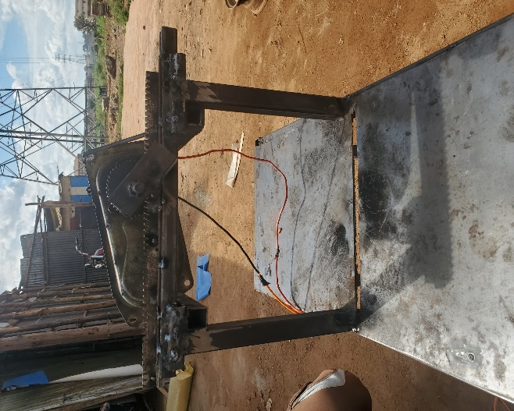

Figure 16 Fabricated machine frame

## 4.2 Design Results

The design of the automatic billet gas cutting machine was based on the required cutting speed, the size of the billet, and the total weight of the moving parts. A DC motor rated at 12V was selected, paired with a 12:1 gearbox to increase torque and reduce speed, ensuring the torch could travel smoothly at the desired cutting speed of 12 mm/s.

The movement of the gas torch was achieved using a rack and pinion mechanism. The rack was 150 mm long with a height of 16 mm and had 24 teeth. This allowed for sufficient travel distance to cover the billet’s width with an extra margin of 15mm on both sides. The pinion was mounted directly onto the motor shaft, and the rotation from the motor provided linear motion to the torch through the rack.

The frame and carriage were made using mild steel, which was chosen due to its availability, affordability, and ability to handle the heat and mechanical stresses involved in the cutting process. The frame was built to support the torch assembly firmly and ensure minimal vibration during operation.

The gas cutting torch was fixed to the carriage using a mechanical clamp. It was connected to oxygen and acetylene gas lines through flexible hoses, with valve controls installed to adjust the flame. The torch height was set manually before testing.

## 4.3 Effect of cutting speed on the billets

Initial trails were conducted a cutting speed of 12mm/s which was selected for cutting the hot billets of $120mm×120mm$. However during testing with billets of 30mm $×30mm$ at room temperature the speed was too fast and as a result the following issues were observed including incomplete cuts as the torch moved faster than the material could heat and melt, irregular edges and uncut zones, increased slag accumulation and poor torch stability due to fast motion over a narrow surface.

Based on these observations the cutting speed was reduced to 6mm/s for subsequent trials and the adjustment allowed more consistent heat penetration, cleaner and complete cuts across the billet cross section, improved cut quality and more stable torch operation.

## 4.4 **Performance Evaluation**

A series of basic performance tests were carried out to evaluate how well the system met the design requirements. The focus was mainly on the **cutting speed, linearity of motion**, **stability of the torch**,and **consistency of the flame** during operation.

### **4.4.1 Cutting Speed Test**

The movement of the torch carriage was timed as it traveled the full 150 mm rack distance. Using a stopwatch, the average travel time was recorded over five trials. The results are summarized below:

|  |  |  |  |
| --- | --- | --- | --- |
| **Trial** | **Distance Travelled (mm)** | **Time Taken (s)** | **Speed (mm/s)** |
| 1 | 150 | 12.4 | 12.1 |
| 2 | 150 | 12.7 | 11.8 |
| 3 | 150 | 12.6 | 11.9 |
| 4 | 150 | 12.5 | 12.0 |
| 5 | 150 | 12.4 | 12.1 |

The system consistently performed near the design speed. Minor variations occurred due to friction or start up torque delay. Target speed was maintained within a ±0.2 mm/s margin.

### 4.4.2 Travel torch Accuracy

The torch was tested for straight-line motion by marking the billet surface and observing the flame path.

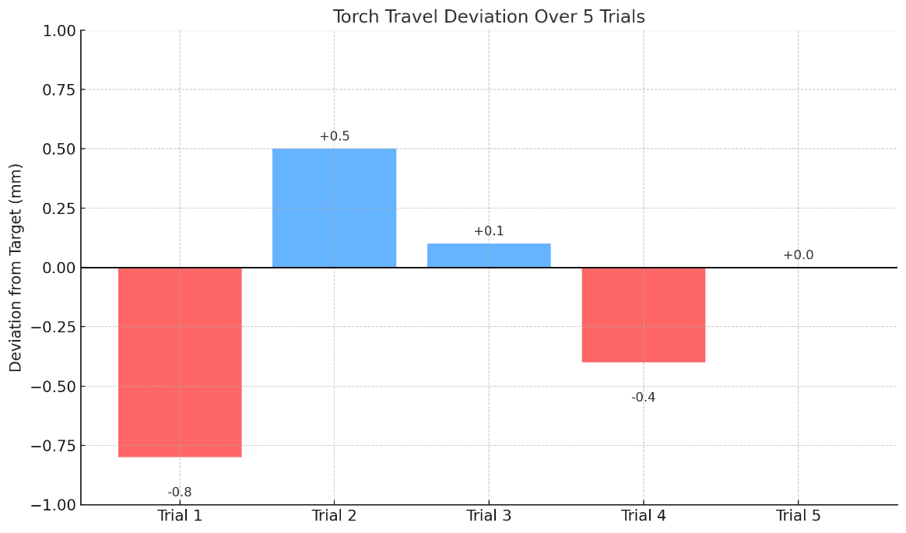

### 4.4.3 Repeatability test

The system was run multiple times to check for repeatable performance. The motor reliably drove the torch at nearly the same speed, and the flame position remained consistent throughout each trial.

### 4.4.4 Stability and frame control

The torch clamp held the cutting torch firmly in place throughout the tests, and the gas flow remained steady. Manual adjustment of flame size and torch height was required before each test, but once set, the flame remained stable.

### 4.4.5 Control system responsiveness

The control system comprising an Arduino board, motor driver, relays, solenoid valves and ultrasonic sensor, start and stop buttons functioned as expected. On pressing the start button the motor began to rotate in the forward direction moving the torch across the billet. The ultrasonic sensor was also able to detect the billet edge, signaling the Arduino to trigger the start of the operation. The stop button also manually interrupted motor operation when needed confirming proper integration of all the control components

# 5.0 LIMITATIONS, CONCLUSIONS AND RECOMMENDATIONS

## 5.1 LIMITATIONS

During the design, development and testing of the automatic billet cutting machine, several limitations were identified that affected the systems overall performance. These limitations, highlight areas that require refinement before industrial application.

One of the primary limitations of the study was the inability to simulate the actual billet temperature range of 900°C–1000°C during testing. The prototype was developed and evaluated under ambient conditions, which do not fully replicate the thermal behavior of hot billets, including material softening, scale formation, and the dynamic response of the torch to intense radiant heat. This limitation affected the ability to assess the system's thermal durability, torch performance under heat stress, and the thermal expansion.

The gas cutting torch was successfully mounted and moved across the billet path; however, the design lacked a fully automated gas regulation system. Manual control of acetylene and oxygen flow was used during testing, which limits the evaluation of automated flame stabilization, ignition, and pressure control features.

The rack and pinion mechanism exhibited minor alignment issues, these led to uneven motion and minor backlash in high-precision applications.

## 5.2 CONCLUSIONS

This project has successfully demonstrated the design and development of an automatic billet cutting machine utilizing a rack and pinion mechanism powered by a geared DC motor. The system effectively translated rotary motion into horizontal torch movement to enable gas cutting of steel billets. The cutting speed was targeted at 12 mm/s across a travel distance of 150 mm, which matches operational expectations in small- to medium-scale steel processing environments.

From the tests design meets the core objectives of improving safety, reducing human fatigue, and enhancing cutting consistency compared to manual torch handling. The machine’s modular design allows for adaptability to various billet sizes, and its simple mechanism provides a foundation for future integration with more advanced automation technologies.

However, the system in its current form remains a prototype. Its performance under real heat conditions, long-term reliability, and full automation capacity require further validation.

## 5.3 RECOMENDATIONS

Based on the observations and findings of this study, several recommendations are proposed to guide future development, testing, and deployment of the automatic billet cutting machine:

The design lacked a feedback loop to adjust the speed and position dynamically thus including a closed-loop feedback system using rotary encoders, limit switches, and temperature sensors would enable more precise and consistent cuts

The machine should be tested on billets heated to operational temperatures (900°C–1000°C). This testing will provide accurate data on torch flame behavior, component heat resistance, and system reliability in thermally aggressive environments.

The gas valves had to be manually opened, incorporating solenoid-controlled gas valves and pressure regulators will allow automatic start or stop of the gas flow, improve flame control, and reduce safety risks.

**I recommend** incorporating dual or multi-torch setups, which would allow simultaneous cutting of multiple billets or sections. This would improve production rates and machine efficiency in larger steel plants.

# REFERENCES

Wu, X.,2009, *Meshing Theory of Gears*, China Machine Press, Beijing

Budynas, R. G., & Nisbett, J. K. (2020). *Shigley's Mechanical Engineering Design* (11th ed.). McGraw-Hill Education.

Khurmi, R. S., & Gupta, J. K. (2005). *A Textbook of Machine Design* (14th ed.). Eurasia Publishing House

International Finance Corporation. (2007). *Environmental, Health, and Safety Guidelines for Integrated Steel Mills*. World Bank Group.

Rehfeldt, K., & Rehfeldt, R. (2012). *Continuous Casting of Steel*. Wiley-VCH.

Hughes, A. (2013). *Electric Motors and Drives: Fundamentals, Types and Applications*

Mohan, N. (2011). *Electric Machines and Drives: A First Course*. Wiley.

Maitra, G. M. (2001). *Handbook of Gear Design* (2nd ed.). Tata McGraw-Hill Education.

NPTEL. (n.d.). *Mechanical Drives – Rack and Pinion Mechanism*.

American Welding Society. (2020). AWS C4.1M/C4.1:2010 – Oxyfuel Gas Cutting. AWS Standards.

Lancaster, J. F. (1999). The Physics of Welding

Bolton, W. (2021). Mechatronics: Electronic Control Systems in Mechanical and Electrical Engineering.

Juvinall, R. C., & Marshek, K. M. (2020). Fundamentals of Machine Component Design

Bhandari, V. B. (2010). Design of Machine Elements

Norton, R. L. (2011). Machine Design: An Integrated Approach

Groover, M. P. (2015). Automation, Production Systems, and Computer-Integrated Manufacturing

*ISO 9013:2017 – Thermal cutting — Classification of thermal cuts — Geometrical product specification and quality tolerances*. International Organization for Standardization.

ASME. (2021). *Y14.5-2018 – Dimensioning and Tolerancing*. American Society of Mechanical Engineers.

Erdman, A. G., Sandor, G. N., & Kota, S. (2001). Mechanism Design: Analysis and Synthesis

Uicker, J. J., Pennock, G. R., & Shigley, J. E. (2017). Theory of Machines and Mechanisms

Kalpakjian, S., & Schmid, S. R. (2014). Manufacturing Engineering and Technology (7th ed.). Pearson.

Messler, R. W. (2004). Principles of Welding: Processes, Physics, Chemistry, and Metallurgy. Wiley-Interscience.

hapman, S. J. (2011). Electric Machinery Fundamentals (5th ed.).

Rashid, M. H. (2014). Power Electronics: Circuits, Devices and Applications

Nasar, S. A. (1995). Electric Machines and Power Systems: Volume I. McGraw-Hill

Spong, M. W., Hutchinson, S., & Vidyasagar, M. (2006). Robot Modeling and Control. Wiley.

Mikell, P. G. (2011). Industrial Robotics: Technology, Programming, and Applications

Bishop, R. H. (2007). The Mechatronics Handbook

Giesecke, F. E., Mitchell, A., Spencer, H. C., Hill, I. L., & Dygdon, J. T. (2011). Technical Drawing (14th ed.). Pearson.

American National Standards Institute (ANSI). (2018). ANSI Y14.36M – Surface Texture Symbols. ANSI.

ISO. (2011). ISO 4063:2011 – Welding and allied processes – Nomenclature of processes and reference numbers. International Organization for Standardization.

# APPENDIX I: SOURCE CODE

#![no_std]

#![no_main]

use arduino_hal::{delay_ms, simple_pwm::{IntoPwmPin, Timer0Pwm}};

use panic_halt as _;

#[arduino_hal::entry]

fn main() -> ! {

let dp = arduino_hal::Peripherals::take().unwrap();

let pins = arduino_hal::pins!(dp);

let system_btn = pins.a5.into_pull_up_input(); // System ON/OFF

let dir_btn = pins.d12.into_pull_up_input(); // Direction control

let speed_btn = pins.d11.into_pull_up_input(); // Speed control

// RGB LED (for gas indicator)

let mut red_led = pins.d8.into_output(); // Gas ON

let mut green_led = pins.d7.into_output(); // Gas OFF

let mut solnoid = pins.a3.into_output(); // Solenoid control

// RGB LED (for ignition indicator)

let mut red_led2 = pins.d3.into_output(); // Ignition ON

let mut blue = pins.d4.into_output(); // Ignition OFF

// BTS7960 motor control

let tc0 = Timer0Pwm::new(dp.TC0, arduino_hal::simple_pwm::Prescaler::Direct); // Timer0 for PWM

let mut left_pwm = pins.d5.into_output().into_pwm(&tc0);

let mut right_pwm = pins.d6.into_output().into_pwm(&tc0);

let mut left_dir = pins.d9.into_output();

let mut right_dir = pins.d10.into_output();

// en_pwm.enable();

let mut speed: u8 = 255;

let min_speed = 100;

let speed_step = 30;

right_pwm.enable(); // Enable right motor PWM

left_pwm.enable(); // Enable left motor PWM

// State vars

let mut increasing = false;

let mut system_on = false;

let mut dir_forward = true;

loop {

if system_btn.is_low() {

arduino_hal::delay_ms(250);

system_on = true;

} else {

arduino_hal::delay_ms(250);

system_on = false;

}

if system_on {

blue.set_low(); //Motor OFF

red_led2.set_high(); // Ignition ON

arduino_hal::delay_ms(1000);

red_led2.set_low();

blue.set_high();

arduino_hal::delay_ms(1000);

red_led2.set_high();

blue.set_low();

red_led.set_high(); // Gas ON

solnoid.set_high();

green_led.set_low();

arduino_hal::delay_ms(1000);

red_led2.set_low();

loop{

if system_btn.is_low() {

system_on = false;

arduino_hal::delay_ms(250);

break;

}

// Direction control

if dir_btn.is_low() {

arduino_hal::delay_ms(250);

dir_forward = !dir_forward;

if red_led2.is_set_high() {

red_led2.set_low();

} else {

red_led2.set_high();

}

}

if dir_forward {

right_dir.set_low();

left_dir.set_high();

} else {

right_dir.set_high();

left_dir.set_low();

}

// Speed control

if speed_btn.is_low() {

arduino_hal::delay_ms(250);

if increasing {

blue.set_high();

speed += speed_step;

if speed >= 255 {

speed = 255;

increasing = false;

}

} else {

blue.set_low();

if speed > min_speed {

speed -= speed_step;

} else {

increasing = true;

}

}

if dir_forward {

right_pwm.set_duty(0);

left_pwm.set_duty(speed);

} else {

left_pwm.set_duty(0);

right_pwm.set_duty(speed);

}

}

}

} else {

red_led.set_low(); // Gas OFF

solnoid.set_low();

green_led.set_high();

left_pwm.set_duty(0);

right_pwm.set_duty(0);

left_dir.set_low();

right_dir.set_low();

}

arduino_hal::delay_ms(50);

}

}

# APPENDIX II: WORKPLAN

|  |  |  |  |  |  |  |  |  |  |
| --- | --- | --- | --- | --- | --- | --- | --- | --- | --- |
| **Activity** | **Sept** | **Oct** | **Nov** | **Dec** | **Jan** | **Feb** | **Mar** | **Apr** | **May** |
| 1. Topic selection & supervisor approval | 🔵 |  |  |  |  |  |  |  |  |
| 2. Literature review |  | 🟢 | 🟢 |  |  |  |  |  |  |
| 3. Define objectives & methodology |  | 🟢 | 🟧 |  |  |  |  |  |  |
| 4. Design and engineering calculations |  |  |  | 🟨 | 🟨 |  |  |  |  |
| 5. SolidWorks model  Ling |  |  |  | 🟨 | 🟨 |  |  |  |  |
| 6. Procurement of materials |  |  |  |  |  | 🔴 |  |  |  |
| 7. Fabrication & assembly |  |  |  |  |  | 🔴 | 🔴 |  |  |
| 8. Testing & performance evaluation |  |  |  |  |  |  | 🔴 | 🟣 |  |
| 9. Report writing |  |  |  |  |  |  |  | 🟣 | 🟣 |
| 10. PowerPoint & final presentation prep |  |  |  |  |  |  |  |  | 🟣 |

# APPENDIX III BUDGET

|  |  |  |  |  |
| --- | --- | --- | --- | --- |
| **No.** | **Item Description** | **Unit Cost (UGX)** | **Quantity** | **Total Cost (UGX)** |
| 1 | 24V DC Motor with gearbox | 100,000 | 1 | 100,000 |
| 2 | Rack and pinion set | 50,000 | 1 | 50,000 |
| 3 | Gas cutting torch (oxy-acetylene) | 20,000 | 1 | 20,000 |
| 4 | Oxygen gas cylinder refill | 10,000 | 1 | 10,000 |
| 5 | Acetylene gas cylinder refill | 10,000 | 1 | 10,000 |
| 6 | Mild steel for frame & carriage | 50,000 | 1 | 50,000 |
| 7 | Guide rails | 5,000 | 2 | 5,000 |
| 9 | Electrical wiring and switches | 20,000 | 1 | 20,000 |
| 10 | Control unit (Arduino + relay + power) | 105,000 | 1 | 105,000 |
| 11 | Cutting, welding & drilling | 50,000 | 1 | 50,000 |
| 12 | Surface finishing and painting | 5,000 | 1 | 5,000 |
| 13 | Transport and logistics | 10,000 | 1 | 10,000 |
|  | **Grand Total** |  |  | **435000 UGX** |

# APPENDIX IV

